Group membership tracker:
Fed by script results to track what security group requests need to be made
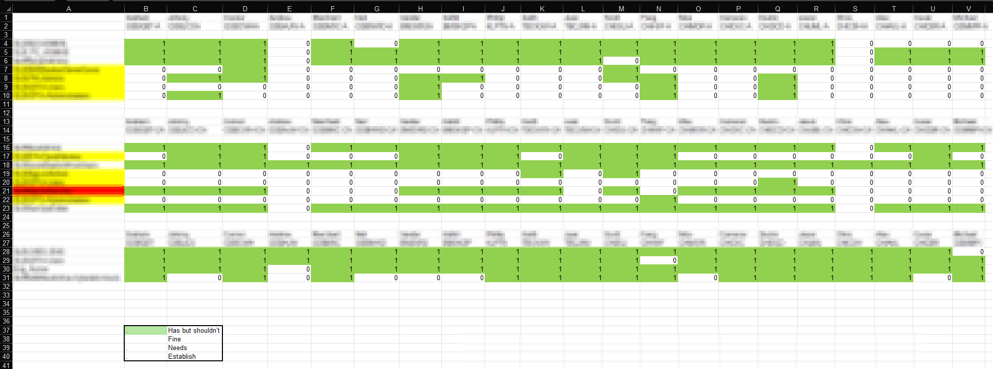
Onboarding checklist (documented):
Pre-start:
- Add to team email distribution list
- Add to Engineering collaboration space
- Add to department + director chat
- Add to department chat
- IT Service Management (ITSM) roles defined and requested
- Forward on regular calendar appts (including team call, CISO open office hour call)
- Set up 1-1 with manager
- Forward Architect call
Post-start:
- Org chart walkthrough
- ITSM & Dashboard walkthrough
- Paid Time Off (PTO) process
- Information Security Management System (ISMS) walkthrough
- Team website walkthrough – private and public
- Confirm that all mandatory courses completed in Learning Management System (LMS)
- Save signed copy of Privileged Access Management (PAM) attestations
- Creation of privileged server administrator account
- Creation of privileged cloud administrator account
- Enterprise Password Vault (EPV) access
- Add to role-based groups for file share and server access
- Security Information and Event Management (SIEM) access
- Change Management training
- “About me” page
- Team Bio updated
- Disaster Recovery system registration
- Jump server access
- Cloud access requests
- MFA group management group
- ITSM group access
- Malware scanning system access
- Team 1-1 intro sessions
- Detection and Response support portal
- Detection and Response management console access
- Vulnerability management console access
- Disk encryption management console access
- Security Orchestration, Automation, and Response (SOAR) management console access
- Adhoc sessions with each subject matter expert (SME)
Onboarding process (undocumented):
Pre-start:
- Account is created by HR
- Distribution lists based on team structure are added
- Reach out to new member via personal channel to gather info for team welcome email
- Send team welcome email
- Request update to org chart

